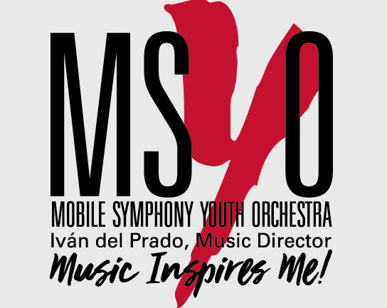

MOBILE SYMPHONY YOUTH ORCHESTRA
Dr. Iván del Prado, Music Director
NEW: CHAMBER STRINGS for Intermediate and Advanced String Players

Keep playing your instrument during summer, polish your skills and learn new ones under the expert guidance of a professional string teacher artist. Make new friends, discover the secrets of playing chamber music, learn original repertoire, and just have fun playing in a smaller string ensemble!
Five sessions total – Duos, trios, quartets, etc. / Music will be provided in advance

Who: Violin, viola, cello or string bass players with 4+ years of experience
Age: 13-21 years old
When: All Thursdays in July starting on July 2, 2020 at 11 AM, 1:00 PM and 3:00 PM
Where: Larkins Center, 257 Dauphin St. Mobile, AL 36602
Teacher Artists: Ivan del Prado and Daniela Pardo
Fee: $90 (Five one hour and a half sessions)
Minimum enrollment: 2 students per group

Chamber Strings Proficiency Requirements:
- At least 4 years playing your instrument. Private lessons are recommended.
- Violin: G major 3-octave scale and arpeggio - Suzuki Book 4 or equivalent
- Viola: C major 3-octave scale and arpeggio - Suzuki Book 4 or equivalent
- Cello: C major 3-octave scale - Suzuki Book 3 or equivalent
- Bass: G or F 2-octave major scale and arpeggio - Suzuki Book 2 or equivalent

For more information and to register: Please call 251-432-2010 or email us at
Daniela Pardo daniela@mobilesymphony.org or
Ivan del Prado ivandelprado@mobilesymphony.org

