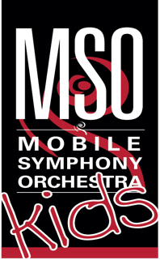 CHAMBER STRINGS FOR INTERMEDIATE/ADVANCED STRING PLAYERS

JOIN the NEW Mobile Symphony Chamber Strings in Downtown Mobile, AL.
Play more advanced repertoire, polish your string techniques and learn new ones, perform exciting music and make new friends that also LOVE playing violin, viola, cello or bass!
This training ensemble will prepare you to join the Mobile Symphony Youth Orchestra.

When: Mondays, 4:30 PM – 6:00 PM
(90 minutes for 25 weeks starting Monday, August 24, 2020)
Where: Larkins Center, 257 Dauphin St. Mobile, AL 36602
Conductor: Daniela Pardo
Minimum Enrollment: 8 students
Fee: $390 – Music will be provided in advance
Register at: mobilesymphony.org or call (251)432-2010

Social distance guidelines will be followed:
One-way entrance, one-way exit, 6 feet apart seating during class.

Chamber Strings Proficiency Requirements:
- At least 3 years of playing experience on their instrument
- Violin: 3-octave G major scale and arpeggio. Suzuki Book 3 or equivalent.
- Viola: 3-octave C major scale and arpeggio. Suzuki Book 3 or equivalent
- Cello: 3-octave C major scale and arpeggio. Suzuki Book 2 or equivalent
- Bass: G or F 2-octave major scale. Suzuki Book 2 or equivalent.
- Private lessons are required
For more information and to register, please contact Daniela Pardo at 251-432-2010 or daniela@mobilesymphony.org

